Name:________________________________________

The objective of this project is to educate you about the wonders of buying and owning a car. You are going to be researching three separate cars.
The 1st Automobile will be a car that you could afford right now depending on your income. If you can only afford a car that is $500 -$2,500 then thats what your choice will be. If your a little bit richer and can afford a car that is in the $5,000 - $10,000 range thats fine as well. If you simply just don’t care at all then I would suggest you simply go on Craigslist and pick a car at random.
The second Automobile will be an affordable new car. Maybe down the road when you have a full time job you will be able to afford this car. Again it has to be in your price range. No Ferrari or Lamborghini here. Again if you don’t know what you want go to a Automobile company’s website and pick one at random.
The last car your going to research is your dream car. This is were you can see how much it would actually cost to own that Ferrari or Lamborghini you always wanted.
Once you have chosen your car it is now time to do some research. I would like you to find the following bits of information for me and put them in this chart just like i did with my example. On the next few pages it will tell you how to easily find this information on KBB.com and fueleconomy.gov.
Good luck and have fun with this!!
 | Affordable Car; New or Used | Affordable New car | Dream Car
Car Name | Ex. Kia Forte Coupe
MSRP | $16,849
Total Cost to own after 5 years | $38,841
Warranty | 5 Yr./ 60000 Mi
Drive Type | Front wheel drive
Transmission Type | 6-spd Automatic
Country of Origin | Korea
Country of Assembly | Korea
MPG  City/Highway | 24/33
Type of Fuel | Regular unleaded
Safety Rating | 4 Star
Number of Airbags | 10
Insurance | $2,203
Cost to Drive 25 Miles | $3.01
Fuel to Drive 25 Miles | 0.9 gallons
Cost to Fill Tank | $43
Tank Size | 13.7 gallons
Annual Fuel Cost | $1,800

Kelly Blue Book

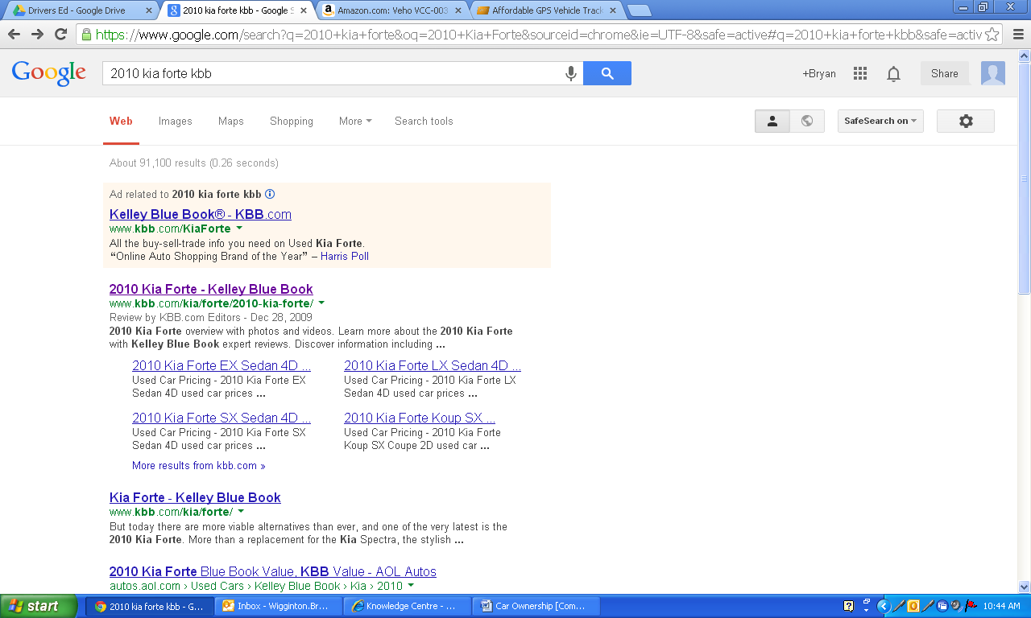

Simply Google the car of your choice. Ex. 2010 Kia Forte kbb
And then click the search result with kbb in the title.

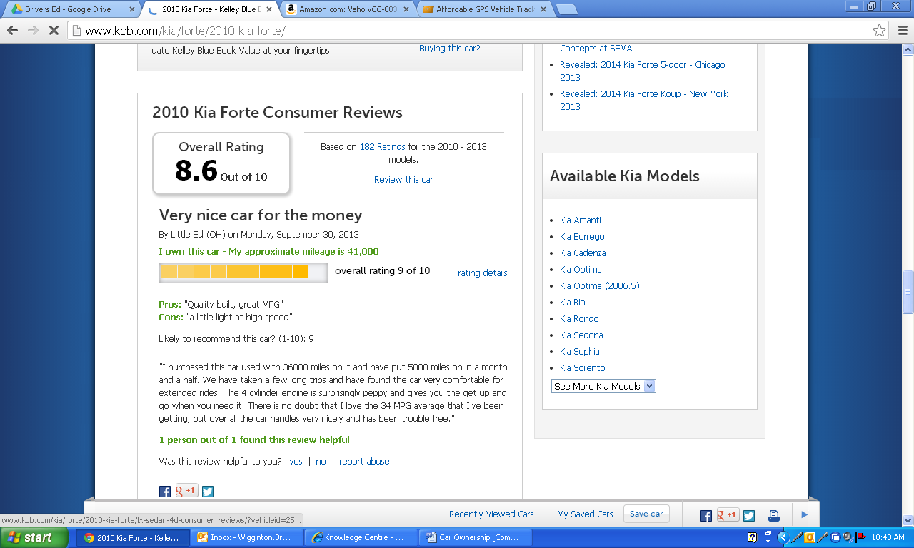

Scroll down the page until you get to the review section. Click on the blue review link.

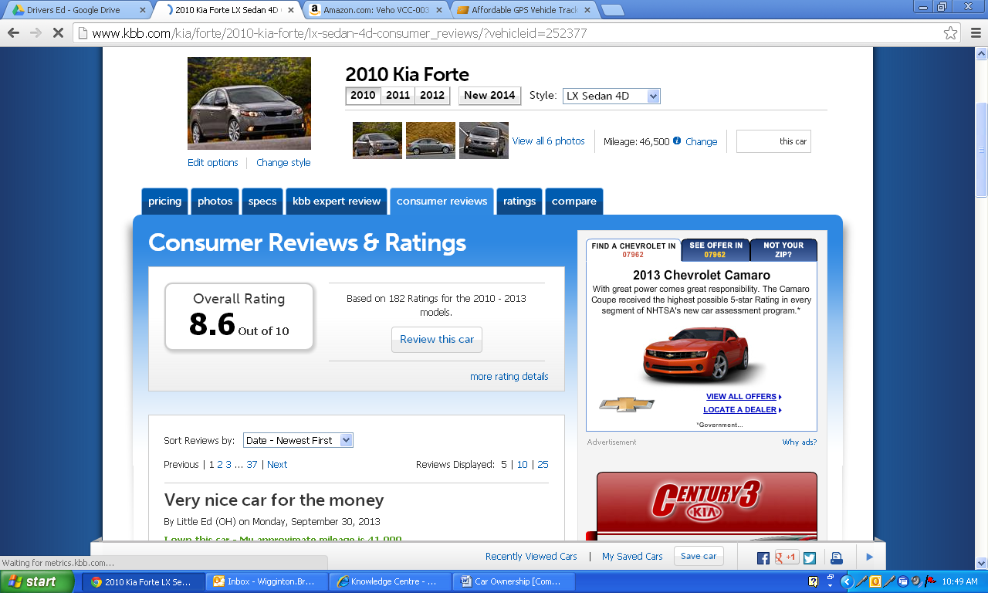

Once here. Click on the tab that says “specs”

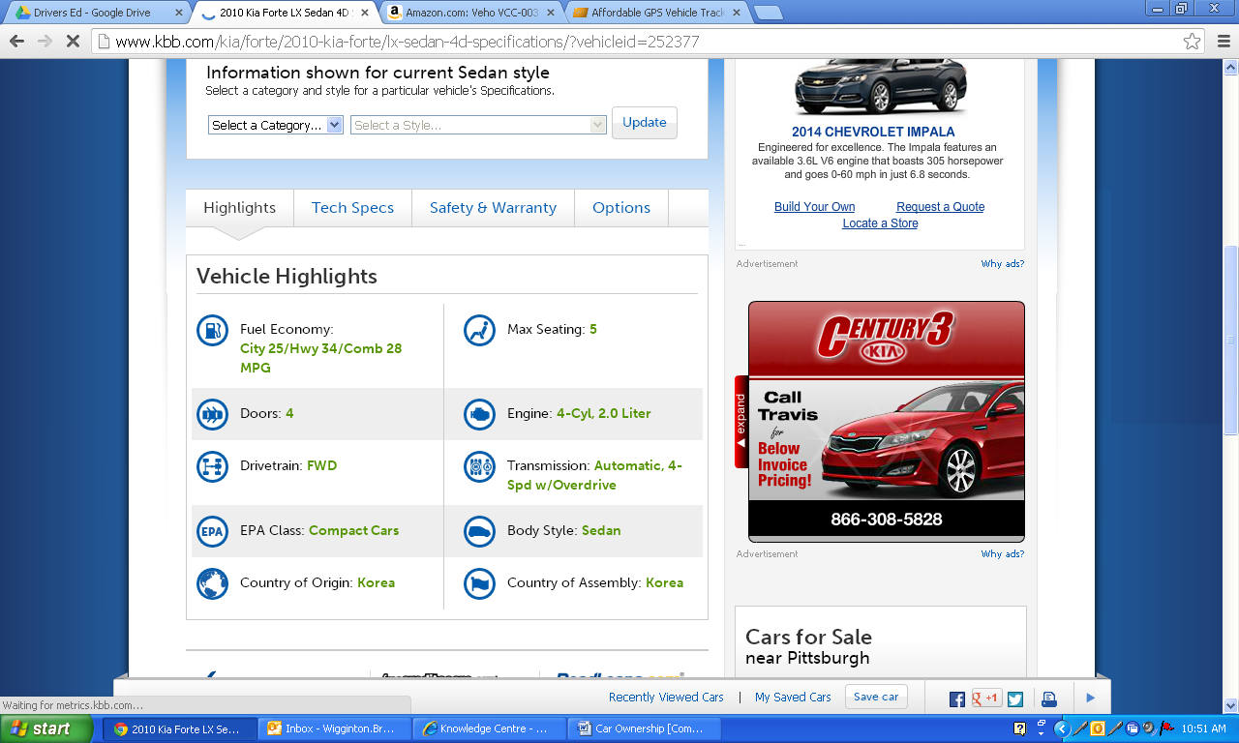
From here you should be able to find most of the information you need. You will also want to click on the Tech Specs and the Safety & Warranty Tabs.

Fueleconomy.gov

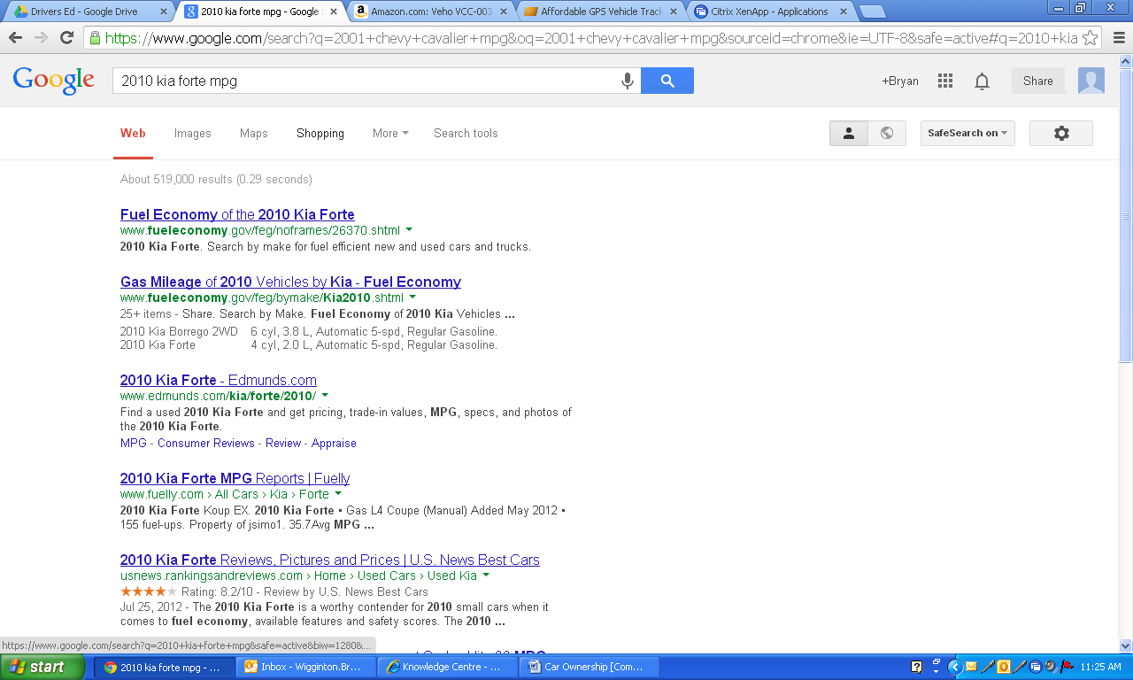

Simply google your car with the year make and model and then “mpg”
Click on the result for fueleconomy.gov

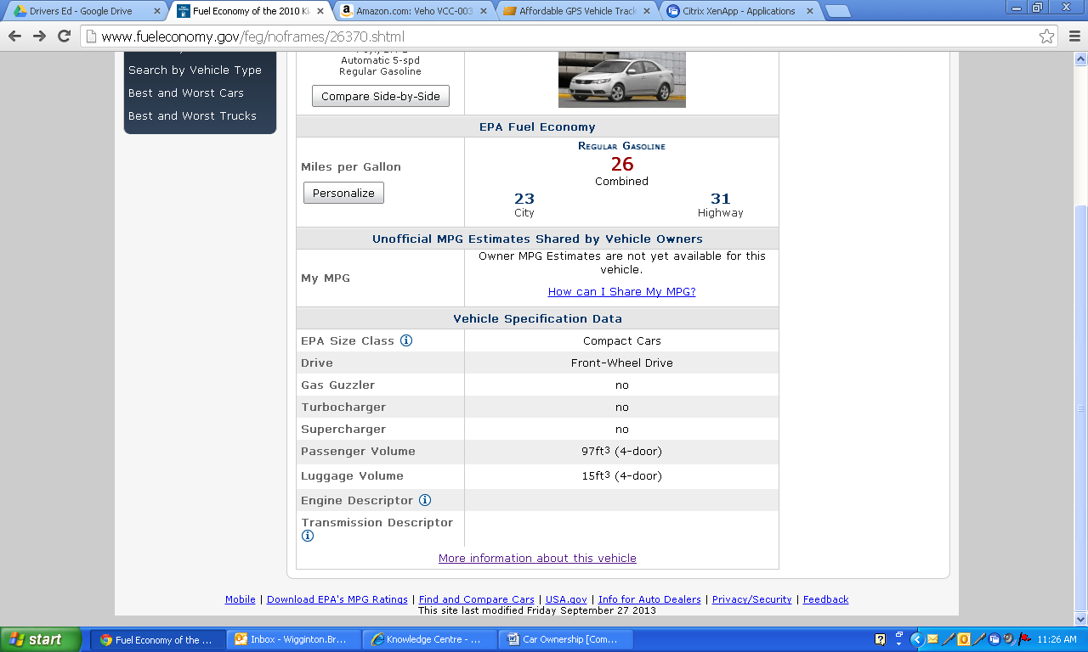

Click on the link at the bottom of the page that says more information about this Vehicle.

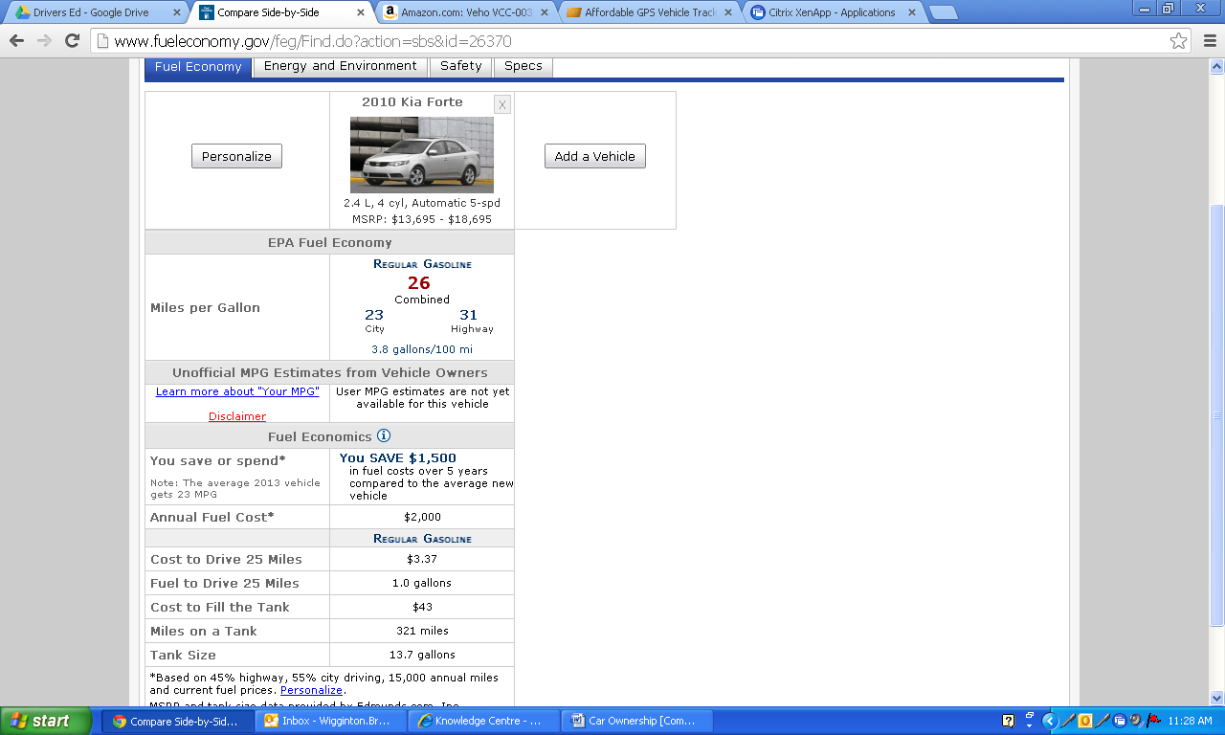

This page should have all the information you need

